Fresh Morning,

This is to request for cancellation of 10mt of actual good received for our previous transaction for Yeast Pro 60% (Inphilco) under PO#31803 last December 07, 2021. The said 10mt will be inputted to different PO number due to price variation and only 1750 should be retained in the Actual Good column.

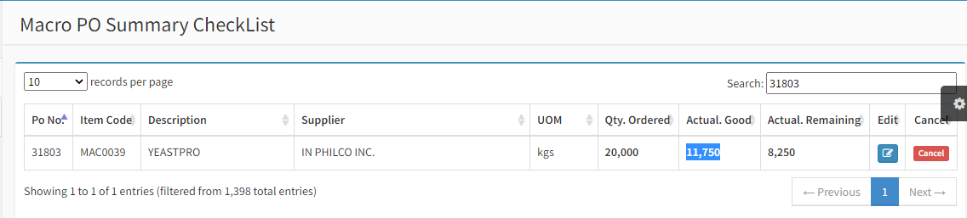

Thank You